Software Requirements
Specification

A Mobile Application for Facility Management

Team
GroupT2
Members
• yusuf sallam 13004663
• ⁠adam amr 13004957
• ⁠ali tamer 13003448
• ⁠seif salem 13006958
• ⁠mohamed amgad 13001129
• ⁠ali alnaggar 13006984
• ⁠adham aly 13002404
• ⁠Ahmed Yasser 13007130

Tutorial Details
T-2 | Mr. Moamen Alaa Mostafa Attia

1. Introduction
This Software Requirements Specification (SRS) defines the requirements for CampusCare, a mobile facility management application for the GIU community. The system enables students and staff to report infrastructure, maintenance, sustainability, and cleanliness issues (for example, broken doors, flickering lights, open windows while AC is running, and overflowing trash cans) through a formal digital process. It also enables the Facility Management team to receive issues, assign personnel, track progress, and update status in a closed loop visible to relevant users. The intended audience includes the project team, teaching staff, and stakeholders, and this document will evolve as requirements are refined.

1.1 Product Vision & Scope
CampusCare aims to provide a simple and fast way for GIU community members to report campus facility issues and follow resolution progress. The Milestone 1 scope focuses on two operational roles: Reporter and Resolver. A Reporter can create a ticket with a photo, short description, category, and location, then track status updates. A Resolver can view assigned tickets, update status, and close resolved tickets. Authentication allows only GIU email accounts and requires email verification before full access. The product goal is low friction reporting with clear and intuitive user experience.

1.2 Definitions and Acronyms
SRS: Software Requirements Specification
MVP: Minimum Viable Product
GIU: German International University
Ticket: A digital record of a reported campus issue
Reporter: A GIU community member who submits and tracks tickets
Resolver: A facility team member who handles assigned tickets and updates status
Authentication: Process of confirming user identity before access
Email Verification: Confirmation that the user controls a valid GIU email address
FR: Functional Requirement
NFR: Non Functional Requirement
UML: Unified Modeling Language
Manager: Role that assigns tickets to resolvers and monitors progress.
Assignment: Linking an open ticket to a specific resolver.

2. Functional Requirements
Describes what the system should do, first in the form of user stories then as a list of functional requirements for each user/role. A UML use-case diagrams should then be included to link specific features and requirements.

2.1 User stories:
These user stories are a working baseline and may be refined during development as requirements become clearer.
As a Reporter, I want to submit a ticket with photo, location, category, and short description, so that facility issues are reported quickly.
As a Reporter, I want to track ticket status updates, so that I know what is happening after submission.
As a Reporter, I want to receive notifications on key status changes, so that I do not need to check manually.
As a Reporter, I want to view the list of tickets I submitted, so that I can track all my reports.
As a Reporter, I want to log in and log out securely, so that I can access the app safely.
As a Resolver, I get assigned tickets by the manager.
As a Resolver, I want to view only tickets assigned to me, so I can focus on my queue.
As a Resolver, I want to update ticket status while working, so that progress is visible to reporters.
As a Resolver, I want to close tickets with a resolution note, so that each issue has a clear completion record.
As a Resolver, I want to log in and log out securely, so that I can access my assigned work safely.
As a Resolver, I want to add a comment to a ticket, so that I can communicate updates or completion details.
As a Resolver, I want to upload a photo after fixing an issue, so that the repair can be verified.
As a Manager, I want to view open and unassigned tickets, so I can decide what should be handled first.
As a Manager, I want to assign a ticket to a specific Resolver, so ownership is clear.
As a Manager, I want to monitor ticket progress, so I can ensure issues are resolved on time.
As a Manager, I to access the app, via the pre-config
As a Manager, I want to view all submitted issues, so that I can assign and monitor them.
As a Manager, I want to update an issue’s status, so that the system reflects its current state, only after the resolvers’ job is finished
As a Manager, I want to close an issue after it is resolved, so that the system reflects that the issue is completed.
As a Manager, I want to accept accounts or deactivate accounts, so that I can manage access to the system.
As a Manager, I want to view all registered users, so that I can manage system users.

2.1.1 Functional Requirements
These functional requirements are derived from the user stories above and may be refined during development.
User: Reporter
FR-01 (Create Ticket): The system shall allow a verified Reporter to create a ticket with photo, location, category, and short description.
FR-02 (Track Ticket Status): The system shall allow a Reporter to view the current status and status history of tickets submitted by that Reporter.
FR-03 (Status Notifications): The system shall notify a Reporter when the status of one of their submitted tickets changes.
User: Resolver
FR-04 (Manager Queue View): The system shall allow a Manager to view all open and unassigned tickets.
FR-05 (Assign Ticket): The system shall allow a Manager to assign an open ticket to a Resolver.
FR-06 (Monitor Progress): The system shall allow a Manager to view ticket progress across all statuses.
FR-07 (View Assigned Tickets): The system shall allow a Resolver to view tickets assigned to that Resolver only.
FR-08 (Update Status): The system shall allow a Resolver to update ticket status during handling.
FR-09 (Close Ticket): The system shall require a Resolver to provide a resolution note when closing a ticket.
FR-10 (Manager Provisioning): Manager accounts are preconfigured by system configuration and are not created through in-app onboarding.
FR-11: The system shall allow a Reporter to view a list of tickets submitted by that Reporter.
FR-12: The system shall allow a Reporter to log in using valid credentials.
FR-13: The system shall allow a Reporter to log out of the application.
FR-14: The system shall allow a Resolver to log in using valid credentials.
FR-15: The system shall allow a Resolver to log out of the application.
FR-16: The system shall allow a Resolver to add comments to an assigned ticket.
FR-17: The system shall allow a Resolver to upload a photo after completing work on a ticket.
FR-18: The system shall allow a Manager to view all submitted issues in the system.
FR-19: The system shall allow a Manager to update the status of an issue after the Resolver has finished the required work and resolver specific statuses, and at the very start to assign from new.
FR-20: The system shall allow a Manager to close an issue once it has been resolved.
FR-21: The system shall allow a Manager to accept or deactivate user accounts.
FR-22: The system shall allow a Manager to view all registered users in the system.

2.2 UML Use-case Diagram
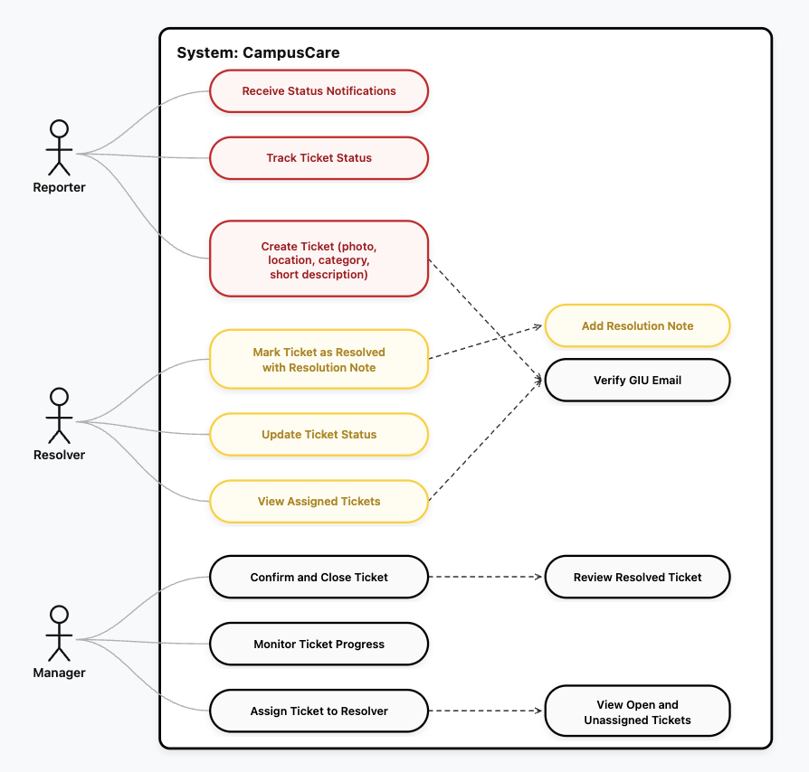
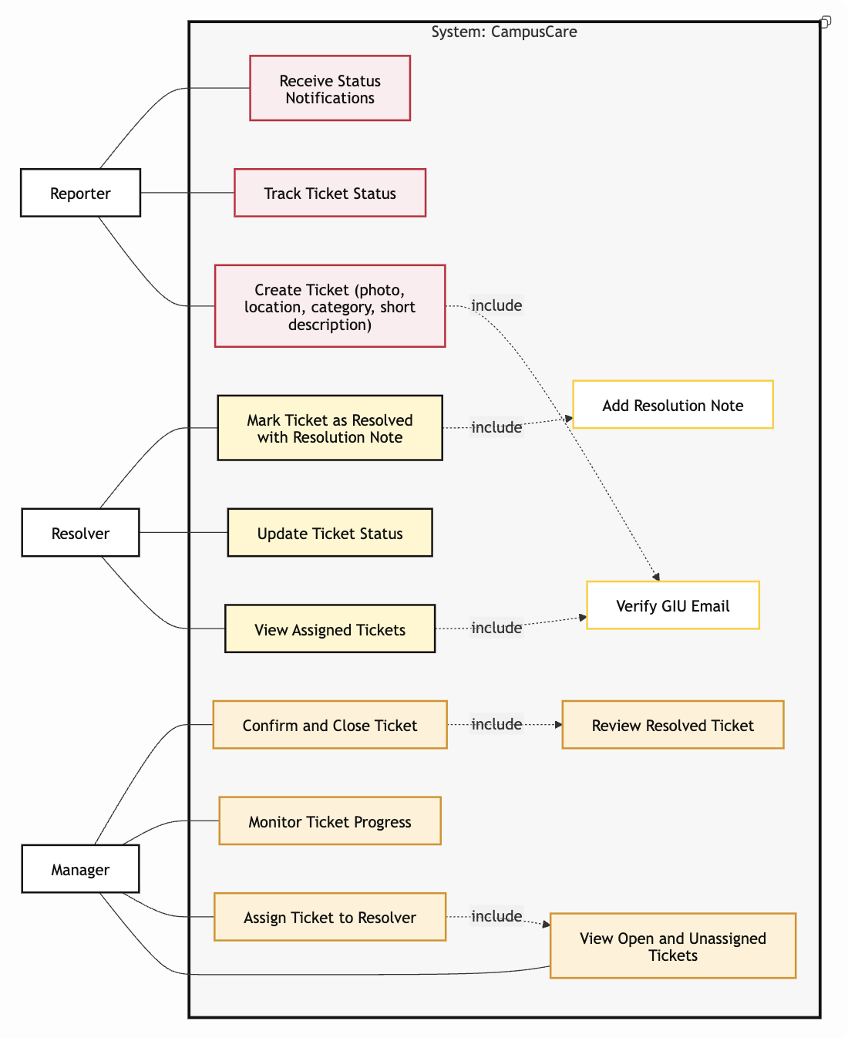

3. Non-functional Requirements:
NFR-01 Usability: A Reporter should be able to submit a ticket in under 1 minute.
NFR-02 Performance: Main screens should load in under 3 seconds on normal network conditions.
NFR-03 Reliability: Failed submissions should be handled gracefully, and users should be able to retry without losing entered data.
NFR-04 Security: Only verified GIU email accounts can access the app.
NFR-05 Access Control: Reporter and Resolver permissions must be enforced.
NFR-06 Availability: The service should be generally always…
NFR-07 Maintainability: The codebase should be modular and easy to update during the semester.

4. Constraints
Ability and resolver onboarding flow, logic and UX, knowing all uni locations to make selection easier for the user and validate properly
Manager accounts are provisioned manually in system configuration for Milestone 1 and are not self-registered in the app.

5. Entity Relation Diagram
This could and probably will change during the actual development of the app
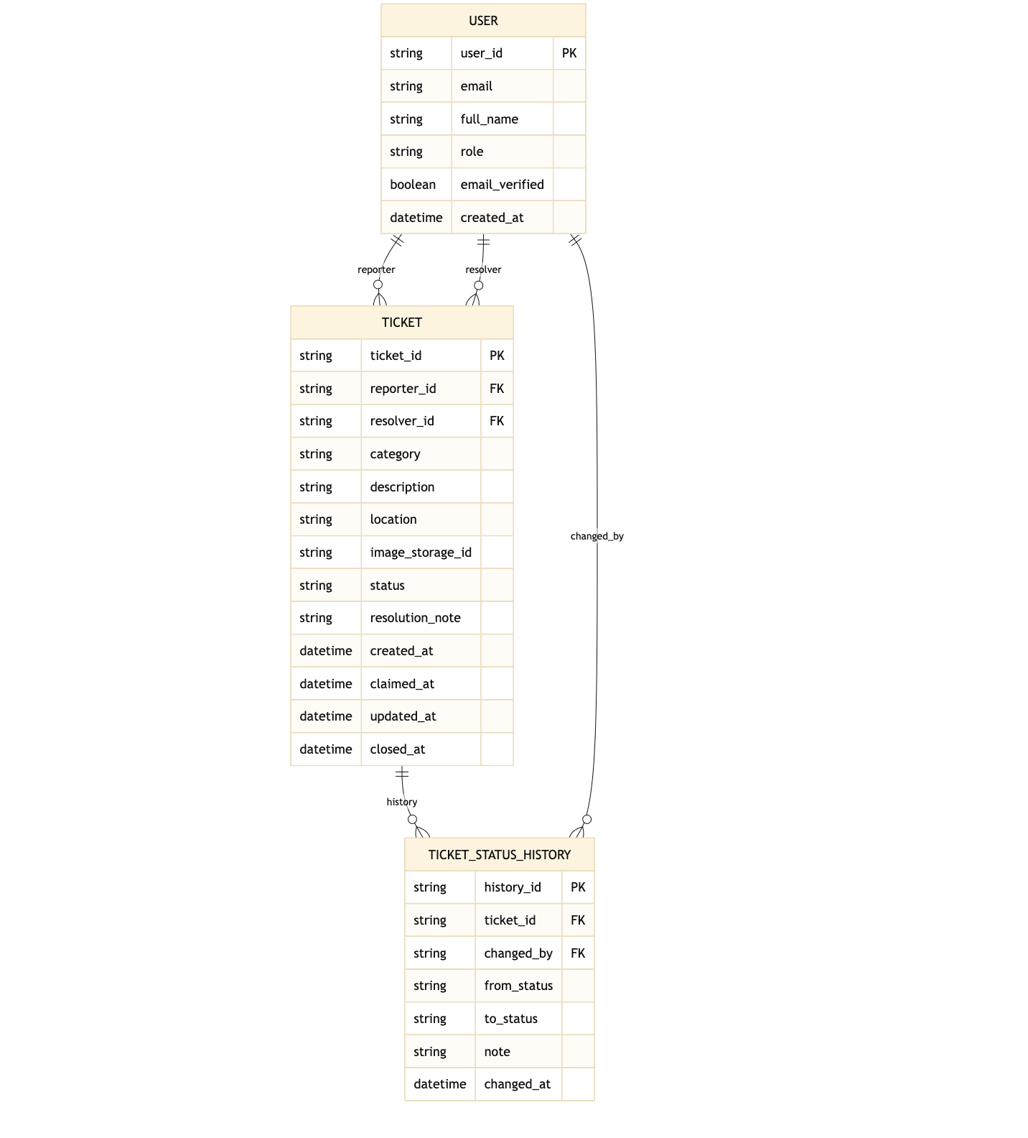

6. Technology Stack
- Backend and Database: Convex
- React native
- File Storage: Convex File Storage will be used to store ticket images
- Response Time: Page load times under three seconds
- Concurrent Users: Support for at least 500 simultaneous users
- API Security: Rate limiting and input validation

7. Future Scope of the Project
- Gamification features such as points, badges, or participation streaks to encourage issue reporting and community engagement.
- Configurable deployment template so the platform can be adapted for environments beyond universities including office campuses, residential compounds, and public facilities… maybe using ai and sdui do avoid strictness in requirements such as has to have “building” or “floor” etc..
- Some type of university map for easier navigation and submission

Backlog ID | User Story ID | Priority
Core System Features
PB-01 | US-R-01 | High
PB-02 | US-R-02 | High
PB-03 | US-R-04 | High
PB-04 | US-M-05 | High
PB-05 | US-R-03 | Medium
Issue Management Features
PB-06 | US-M-01 | High
PB-07 | US-M-02 | High
PB-08 | US-RES-01 | High
PB-09 | US-RES-02 | High
PB-10 | US-RES-03 | High
PB-11 | US-M-03 | Medium
PB-12 | US-M-06 | Medium
PB-13 | US-M-07 | Medium
PB-14 | US-RES-05 | Medium
PB-15 | US-RES-06 | Medium
PB-21 | US-RES-Assignment | High
Authentication & Security
PB-16 | US-R-05 | High
PB-17 | US-RES-04 | High
System Administration (also manager in our case)
PB-18 | US-M-08 | Low
PB-19 | US-M-09 | Low
PB-20 | US-M-Access | High

